Lesson 11 Full Study Guide with Flowcharts

Table of Contents
1. useEffect Hook for Side Effects
2. Dependency Arrays in useEffect
3. Client-side vs Server-side Searching
4. Handling Asynchronous Operations and Errors
5. useCallback for Performance Optimization
6. Automatic and Explicit Data Fetching Strategies
7. useReducer for State Management
8. Conditional Rendering
9. Fetching Data from Public API
10. Visual Flowcharts for Key Concepts

useEffect Hook for Side Effects
The useEffect hook allows React components to perform side effects such as data fetching, subscriptions, or manually changing the DOM after rendering.
Code Snippet:
import React, { useEffect } from 'react';
useEffect(() => {
console.log('Component mounted');
}, []);

Dependency Arrays in useEffect
Dependency arrays in useEffect determine when the effect should re-run. An empty array means the effect runs only once after the initial render.
Code Snippet:
useEffect(() => {
console.log('Runs once');
}, []);

Client-side vs Server-side Searching
Client-side searching filters data on the user's browser, while server-side searching sends queries to the server for filtered results. Server-side is better for large datasets.
Code Snippet:
const filtered = data.filter(item => item.name.includes(searchTerm));

Handling Asynchronous Operations and Errors
Async operations like API calls can be handled using async/await syntax. Errors should be caught using try/catch blocks to ensure reliability.
Code Snippet:
async function fetchData() {
try {
const res = await fetch('https://api.example.com');
const data = await res.json();
console.log(data);
} catch (error) {
console.error(error);
}
}

useCallback for Performance Optimization
useCallback memoizes functions to prevent unnecessary re-creations, improving performance especially in components with frequent re-renders.
Code Snippet:
const memoizedCallback = useCallback(() => {
doSomething();
}, [dependency]);

Automatic and Explicit Data Fetching Strategies
Automatic data fetching occurs on component mount, while explicit fetching is triggered by user actions. Both strategies can be used to optimize user experience.
Code Snippet:
useEffect(() => {
fetchData();
}, []);

useReducer for State Management
useReducer is a React hook for managing complex state logic. It takes a reducer function and initial state, returning the current state and dispatch function.
Code Snippet:
const reducer = (state, action) => {
switch (action.type) {
case 'increment': return { count: state.count + 1 };
default: return state;
}
};
const [state, dispatch] = useReducer(reducer, { count: 0 });

Conditional Rendering
Conditional rendering allows components to display different UI based on state or props. It can be implemented using ternary operators or logical conditions.
Code Snippet:
{isLoggedIn ? <Dashboard /> : <Login />}

Fetching Data from Public API
Fetching data from public APIs can be done using fetch or Axios. The data is usually in JSON format and can be displayed using React components.
Code Snippet:
useEffect(() => {
fetch('https://api.publicapis.org/entries')
.then(res => res.json())
.then(data => setData(data.entries));
}, []);

Visual Flowcharts for Key Concepts
Flowchart: useEffect Lifecycle
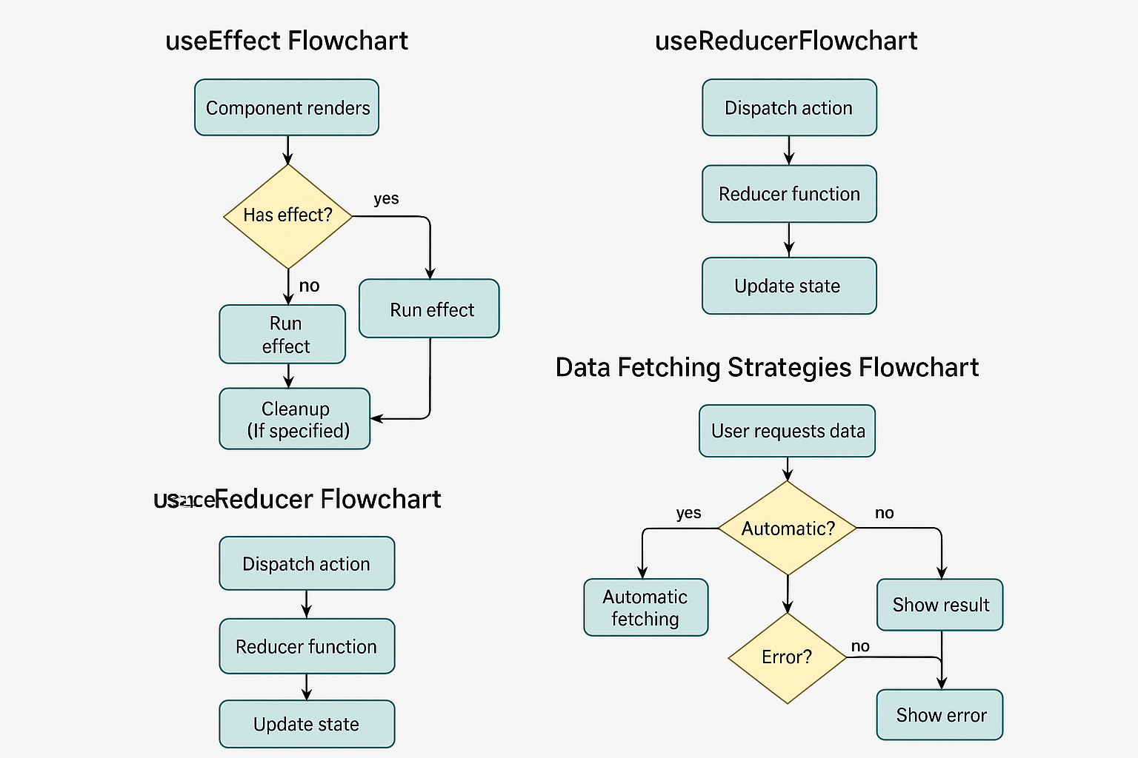
Flowchart: useReducer State Management
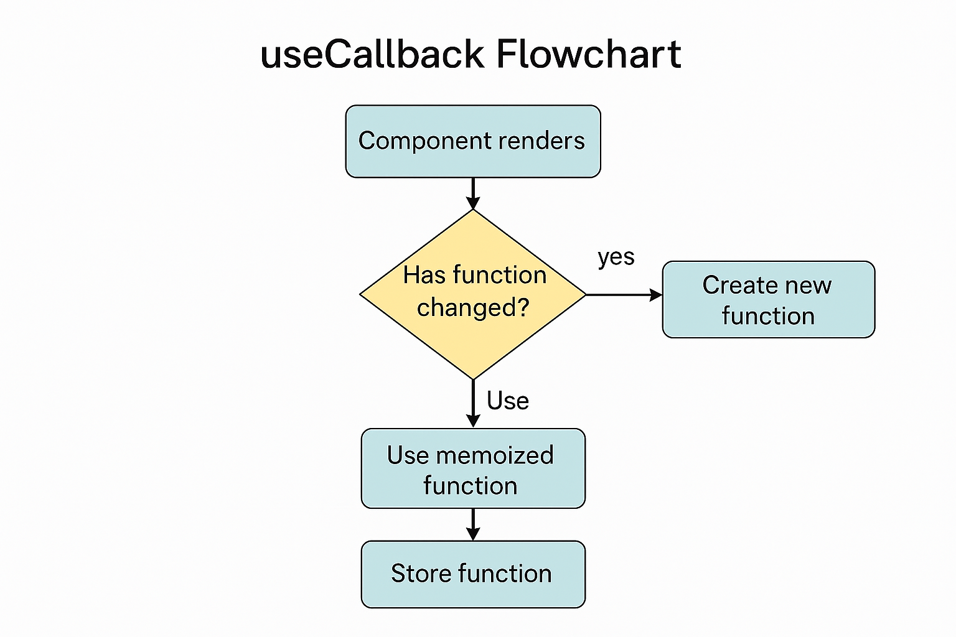
Flowchart: Data Fetching Strategies
Flowchart: useCallback Memoization

